Geotechnical Interpretative Summary
Harrow Bay Offshore Wind · Foundations
Sofie Lindqvist · 18 September 2026 · HB-ENG-REP-0019

1. Scope of investigation
This summary interprets the 2023–2024 site investigation and the pre-installation CPT campaign of February 2026. It was prepared by Oliver Grant (Geotechnical Engineer) and supports the driveability analyses and the position-specific pile designs.
Campaign | Scope | Contractor | Year
Geophysical survey | MBES, SSS, SBP, magnetometer – full array + export route | Survey contractor | 2023
Geotechnical campaign 1 | 40 seabed CPTs to 45 m, 12 boreholes | Geotechnical contractor | 2024
Pre-installation CPTs | 40 CPTs at final positions, 8 seismic CPTs | Geotechnical contractor | 2026

2. Ground model
Unit | Description | Depth below seabed | Typical qc (MPa)
1 | Loose to medium dense fine SAND | 0 – 3 m | 4 – 12
2 | Dense to very dense SAND, occasional shell | 3 – 12 m | 25 – 45
3 | Stiff to very stiff sandy gravelly CLAY (glacial till) with boulders | 8 – 28 m | 2.5 – 5 (fs high)
4 | Very dense SAND and GRAVEL | > 26 m | 40 – 70

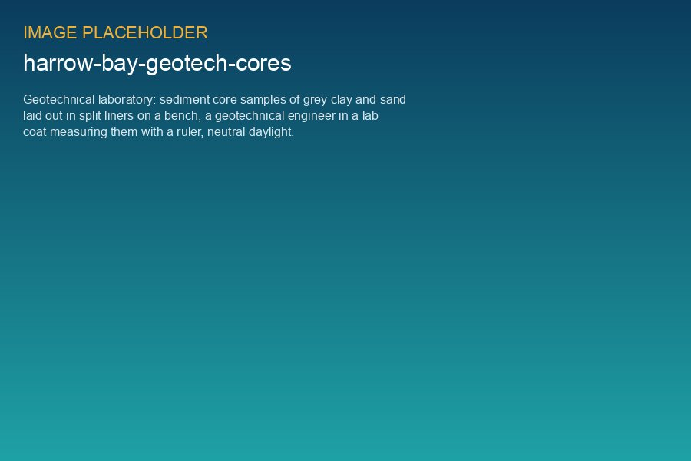
Glacial till samples from borehole BH-07 (string C)

3. Key findings
- Unit 2 is thicker in the south-west (string A), leading to higher blow counts – confirmed during installation (4,655 to 6,015 blows).
- Unit 3 contains boulders up to 1.2 m; no refusal encountered so far.
- At HB-C10 to HB-C13 the top of Unit 4 is 3–4 m shallower than assumed; pile wall thickness increased (CO-007).
- Seabed mobility is low except in the sandwave area of the export route (KP 22–31).

4. Driveability vs. actual
Position | Predicted blows | Actual blows | Deviation
HB-A01 | 5,101 | 4,812 | -6 %
HB-A04 | 5,067 | 5,390 | +6 %
HB-A08 | 5,621 | 5,511 | -2 %
HB-A11 | 5,434 | 5,602 | +3 %
HB-A13 | 6,178 | 5,884 | -5 %

Prediction accuracy is within ±8 %, which confirms the soil model and the SRD parameters used.

